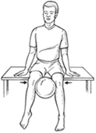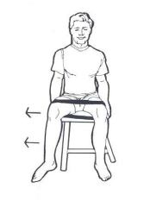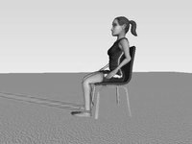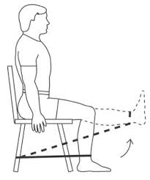

Kick Outs:

-Sitting in a chair, knees shoulder length apart, place band around the thighs near your knees.

-Stretch the band by moving your legs as far apart as you can.

-Hold for 5 seconds and slowly return to starting position.

-Repeat 5 to 10 times.

Ball Squeezes:

-Place a rubber ball between your knees and hold it in place.

-Squeeze the ball and hold for 5 to 10 seconds.

-Repeat this 5 to 10 times.

(If you do not have a ball, put your hands between your knees and perform exercise)

Leg Raises:

-Attach thera-band to ankle of the leg you want to exercise with.

-Secure the other side as show.

-Sit with one leg bent.

-Straighten the other leg out and slowly return back to starting position.

-Repeat 10 to 15 times.

Hamstring Curls:

-Attach one end of the band to a stationary object.

-Wrap the other end to your ankle.

-Move your leg toward your body, hold, then return to starting position.

-Repeat this 10 to 15 times for each leg.

Seated Exercises