Doing the exercises in this handout will help you recover after total knee replacement surgery. Because they strengthen the muscles the support your knee, they can also prevent knee damage. Do the selected exercises with both legs, exactly as you were instructed. Do the best you can without getting to the point of severe pain. If you have any questions about the exercises or your instructions, please do not hesitate to contact your therapist.

**Quad Sets**

* Lay or sit with your leg extended
* Tighten the quad muscles above your knee on the front of you thigh
* Try to push the back of your knee downward
* Hold this position for _________ seconds, repeat this __________ times

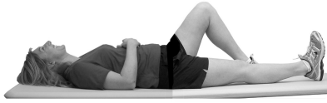

**Total Knee Exercises**

**Knee Extensions**

* Lie on your back with your involved leg bent to about 45 degrees. Put a pillow or towel under you knee for support
* Straighten your leg at your knee.
* Hold this position for __________ seconds
* Return to the starting position
* Repeat this __________ times

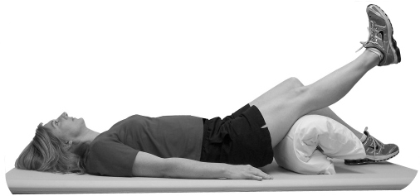

Your Therapist:

Phone Number:

**Heel Slides**

* Lie on your back with your legs straight
* Slide your heel up toward your buttocks
* Return to starting position
* Do this __________ times

