Hip Extenstion
- Stand holding onto a table or wall for balance
- Extend your operated leg backward, keeping the knee straight. Hold this for __________ seconds
- Return to starting position
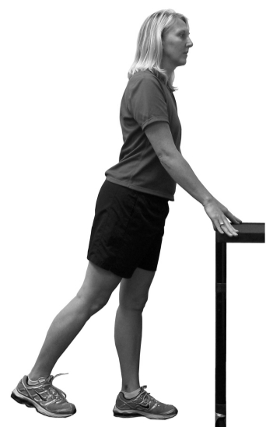

Hip Abduction
- Stand up straight with your weight on you non-operated leg
- Keep you knee straight and move your operated leg outward
- Return to the starting position
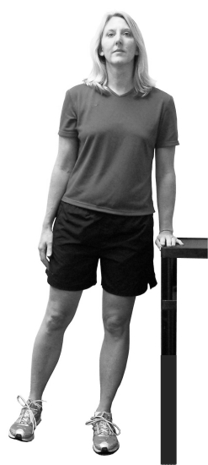

Heel and Toe Raises
- Stand up using a counter or table for balance
- Raise up on your toes as high as you can. Return to starting position and repeat
- Next, put your weight on your heels and raise your toes. Return to starting position and repeat
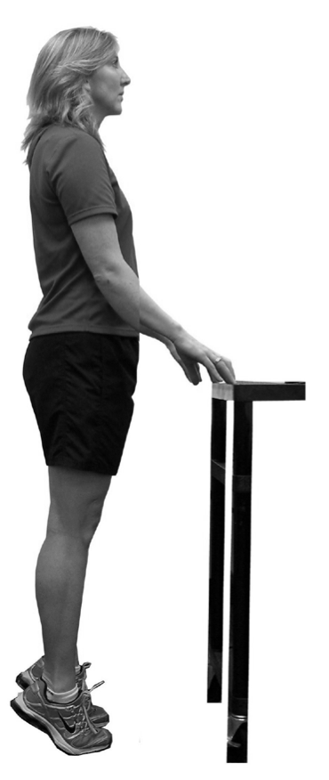

Knee Squats
- Stand on both feet, holding on to the counter for balance if needed
- Bend your knees to 45 degrees
- Return to the starting position
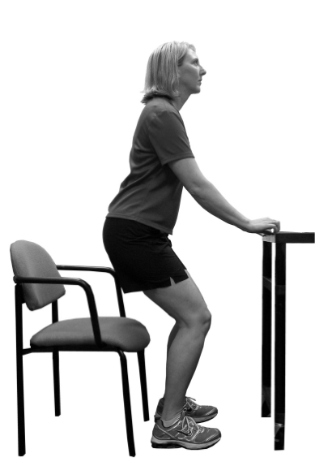
Knee Raises
- Hold onto a table and stand with your feet shoulder-width apart
- Raise your operated knee as high as you can, then lower it
- Repeat with the same knee
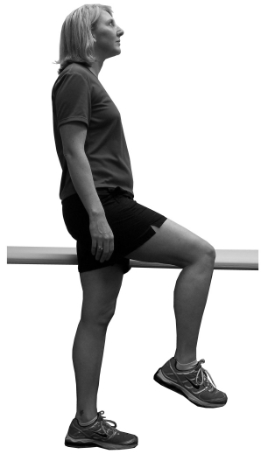

Additional Comments/ Instructions:

Standing Hip Flex
- Stand holding onto to a table or chair for support
- Lift your operated leg up as high as you can while keeping your knee straight
- Lower your leg
- Repeat with the same leg

