

**Total Hip Exercises**

Doing these exercises will help you recover after total hip surgery. Do the selected exercises just like the therapist instructed. Do the best you can without getting to the point of severe pain. If you have any questions please do not hesitate to contact your therapist.

Your exercise instructions:

__________ repetitions each set

__________ sets each time you do the exercise

__________ times everyday

**Buttocks Squeeze**

* Lie on your back with your legs straight
* Squeeze buttocks together
* Hold this position for _______ seconds

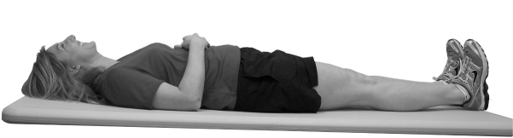

**Heel Slides**

* Lie on your back with your legs straight
* Slide your heel up toward your buttocks
* Return to starting position

Your physical therapist:

Phone number:

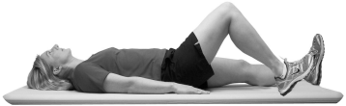

**Hip Abduction**

**Short Arc Quad**

* Sit with your hands behind you for support
* Bend uninvolved leg
* Place a rolled up towel under the knee of your operated leg
* Straighten the operated leg by lifting your foot toward the ceiling, keeping the knee on the towel
* Slowly lower foot

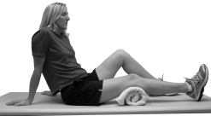

* Lie on your back with your legs together
* Move one leg out to the side, keeping the

knee straight

* 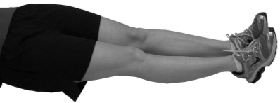Return to starting position

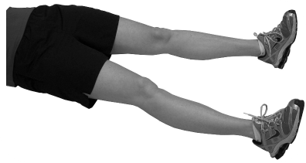

**Straight Leg Raise**

* Lie on a flat surface, resting on your elbows
* Bend your uninvolved leg
* Straighten your operating leg as much as you

can, tightening the thigh muscles

* Raise your heel off the floor or bed _________

inches and hold this position for 5 seconds

* Slowly lower and relax the leg

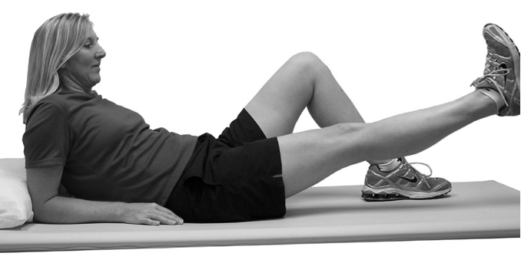

**Quad Sets**

* Lie on your back or sit with one leg

extended

* Tighten the quad muscles(the muscle

above your knee)

* Try to push the back of your knee

downward

* Hold this position for _______ seconds

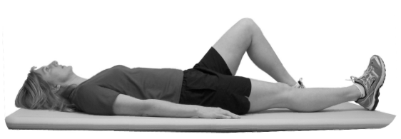

**External Rotation**

* Lie on your back or sit with your legs

straight out in front of you

* Rotate one leg out from your hip,

then return to original position.

rotate the entire leg, not just the

foot

* Repeat this motion with the other

leg.

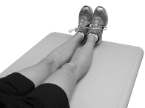

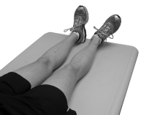

**Sitting Knee Extension**

* Sit your legs bent at 90 degress
* Straighten your operated leg at your knee
* Return to starting position
* 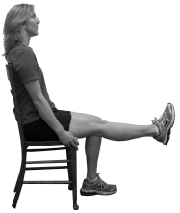

**Hamstring Sets**

* Sit upright with your leg slightly

bent

* Without moving the leg, tighten the

muscles on the back of your leg

* Try to push your heel down
* Hold this position for _________seconds

