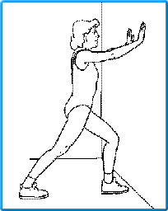 (Total knee)
Runner’s Stretch
- Stand approximately one foot away from a wall or countertop

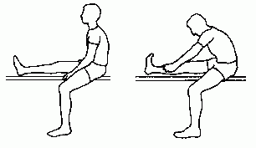
Hamstring Stretch

