

**Piriformis Stretch**

* Lie on your back with both feet flat on the surface and both knees bent
* Pull one knee up to your chest, grasp the knee with your opposite hand and pull it towards the shoulder and hold this stretch for _________ seconds
* Repeat this _________ times for each side

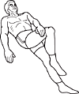

**Double Knee to Chest Stretch**

* Lie on your back with your knees bent and your feet flat on the floor
* Bring one leg to your chest, then the other. Hug your legs with both hands
* Hold for ________ seconds then return to starting position
* Repeat this stretch ________ times

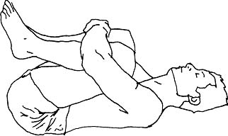

These exercises are designed to help relieve back pain. Only do the exercises selected by your physical therapist. Do the best you can without getting to the point of extreme pain. If you have any questions regarding the exercises or your instructions please do not hesitate to contact your therapist.

Your Therapist:

Phone Number:

**Hooklying trunk rotation**

* Lie on your back with knees bent and feet flat on surface
* Gently drop your knees to one side and turn your head the opposite direction
* Hold this position for ________ seconds
* Repeat this stretch _________ times for each sid

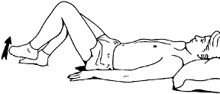

**Single Knee to Chest Stretch**

* Lie on your back with your knees bent and feet on the floor
* Leaving one foot in place, bring one knee toward your chest while pressing your lower back into the floor
* Hold the raised knee with both hands and hug it towards your chest
* Hold the leg in place for ________ seconds
* Repeat this _________ times on that leg
* Repeat stretch with the opposite leg

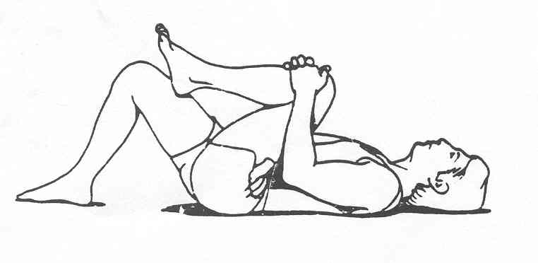

**Back Pain**

**Additional comments/instructions:**

**Bridge Stretch**

* Lie down with your knees bent and arms by your side
* Slowly push your pelvis towards the ceiling
* Hold this stretch for ________ seconds, repeat this stretch _________ times

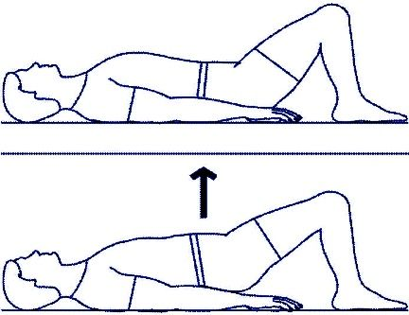

**Hamstring Stretch**

* While siting at the edge of a chair, straighten one leg in front of the body with the heel on the floor
* Sit up straight then try to push the naval towards the thigh without leaning the trunk of the body forwards..
* Hold this for _________ seconds, then repeat__________ times for each leg

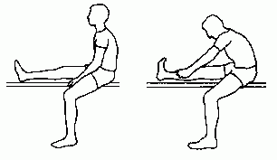

**Abdominal Bracing**

* Lie on your back with your knees bent and feet flat on the floor
* Pull your belly button in toward your spine. Do not flatten or arch your back
* Tighten the abdominal muscles below the belly button. Hold this for _________ seconds
* Do this _________ times

