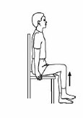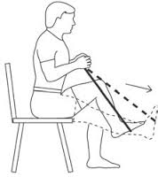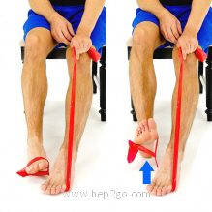

Additional instructions/comments:

Up and Out:

-Begin with both feet flat on the floor. This exercise will be done one leg at a time, so begin with one foot in a loop of the resistance band. Hold the other end with both hands.

-Slowly raise the knee towards your chest, then push the foot out away from your body against the theraband. Hold briefly and slowly return to the starting postion.

-Repeat this 10 times for each leg.

Seated Marching:

-Lift one knee up towards your chest, while keeping your back straight, and return to the starting position.

-Repeat this 10 times for each leg.

Ankle Pumps:

-As shown, wrap one foot with resistance band, step on the band with the other foot and hold the remainder of the band in your hand.

-Place feet hip width apart and flex the exercising toes toward your body. Be sure to keep your heel on the ground.

-Hold this position briefly then return to start. Repeat this 10 times for each foot.