Flexion:

Your therapist: ________________________

Phone number:________________________

If you have any questions, please contact the therapist.
Theraband Exercises for Shoulder Strengthening
-Place one end of the theraband under one foot. With the arm on the same side, lift straight up in front of you and away from your body.
- Repeat this __________times for each side.

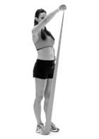

Abduction:
-Place one end of the theraband under your right/ left foot.
-Using the arm on the same side, lift your arm out to the side away from your body.
-Repeat this __________times for each side.
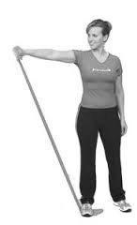

Shoulder Diagonal:
-(A) Place theraband under one foot. Using the opposite arm, pull theraband across your body towards your shoulder.
-Repeat this _________times for each side.
-(B) Place theraband under one foot. Using the arm on the same side, pull theraband across the body diagonally, starting from your hip, toward your shoulder. Repeat this _________times for each side.
(A)
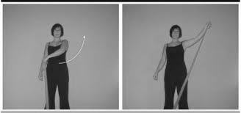
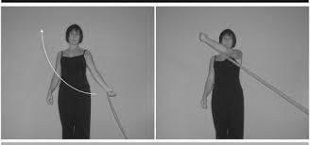
(B)
Shoulder Shrugs:
-Place theraband under both feet. Hold the ends of the band in each hand.
-Keep your elbows straight and lift your shoulders upward. Hold and slowly return to starting postion.
-Repeat this __________times.
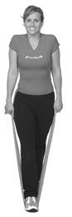

Pull backs:
-Wrap theraband around a table leg or an immovable object. Hold the ends with your hands.
-Pull both arms towards you at the same time, squeezing your shoulder blades together. Hold and slowly return to the starting position.
-Repeat this ____________times.

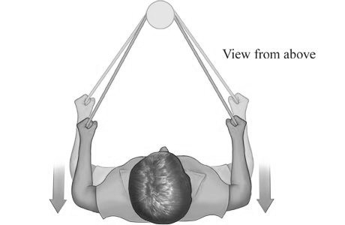
Horizontal abduction:
-Hold theraband out in front of you at shoulder level.
-Pull apart theraband slowly away from your body. (Making a “T” with your body). Return to starting position.
-Repeat this __________times.
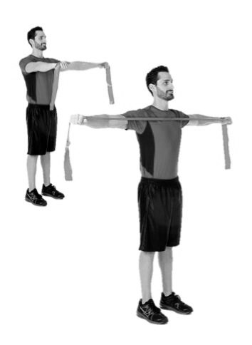
Pull Across:
-Attach one end of the theraband to a stationary object, hold the other end with one hand.
-Elbow next to side, arm at 90 degrees, pull the theraband across midsection.
-Repeat this __________times.
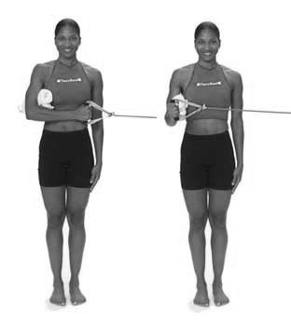
90 degree pulls:
-Attach one end of the theraband to a stationary object, hold the other end with one hand.
-Elbow next to side, arm at 90 degrees, pull theraband towards body(keep arm bent, move elbow towards body).
-Repeat this __________times for each side.
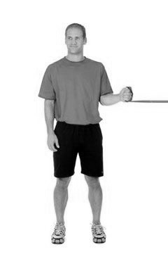

Additional instructions/comments:

